PROJECT TARS

Chris King

CST-451 Capstone Project Requirements Document

Grand Canyon University

Instructor: Professor Mark Reha

Revision: 0.0

Date: 10/15/2022

**ABSTRACT**

The peak of cutting-edge technology can be defined by many different subjects. Embedded systems, cloud computing, API; many of these represent the true power that technology is capable of. However, there is one large, powerful area of technology that cultivates a particular interest; artificial intelligence. What makes AI so powerful is its applicability in the real world. There are almost no limits to what you can apply AI to. From making arguably self-aware robots that can be your best friend, artists, all the way to creating an intelligent, automated process behind your application’s fundamental processes. For this project, an AI model will be created and designed to be able to be mounted on different systems.

The problem with current industry-level AI is its portability; AI today feels more like a software application than an individual entity. The goal of this project is to lay a foundation to solve exactly this problem, by creating an AI model that’s ‘portable’, in that it can be transported from environment to environment with relative ease. With inspiration taken from multiple science-fiction movies, an AI model with this level of portability will kickstart the solution of creating an AI that is more entity than application. The key function to this portability is to give this AI model the ability to learn to perform tasks that it wasn’t explicitly programmed to perform.

| History and Signoff Sheet |
| --- |

**Change Record**

| **Date** | **Author** | **Revision Notes** |
| --- | --- | --- |
| 10/05/2022 | Chris King | Outline subject scope for NLP Conversational capability |
| 10/05/2022 | Chris King | Move SpiderPi to out of scope |
|  |  |  |

| **Overall Instructor Feedback/Comments**  Professor recommends outline scope of conversational capability for NLP by defining a subject. Professor also recommends moving SpiderPi out of scope to over-deliver rather than over-promise. |
| --- |

| **Overall Instructor Feedback/Comments** |
| --- |

**Integrated Instructor Feedback into Project Documentation**

☐ Yes

**TABLE OF CONTENTS**

**Functional Requirements 5**

**Non-Functional Requirements 6**

**Technical Requirements 7**

**Logical System Design 8**

**User Interface Design 9**

**Reports Design 11**

**Functional Requirements**

**Use Cases**

**View Attached Excel Sheet**

**Non-Functional Requirements**

**View Attached Excel Sheet**

**Technical Requirements**

**Use Cases**

Describe the tools and technologies used in the project.

NOTE: Once the technical requirements have been completed, there may be situations where technologies or tools may need to be taken out of scope or changed, possibly due to technical challenges or timeline challenges. Any technologies or tools that are taken out of scope or changed once the project development has started must be approved by the mentor and instructor with justification as to why the functionality is being removed from the project. The following must be updated if any technologies or tools are taken out of scope or changed:

| **Technology or Tool** | **Approval Date** | **Justification** |
| --- | --- | --- |
| **Laptop - 64GB RAM Intel Core I9 RTX 3060** | **09/25/2022** | **Developing and training system** |
| **Raspberry Pi 4 8GB 8GB RAM** | **09/25/2022** | **Device for system to mount** |
| **External SSD 64GB** | **09/25/2022** | **Extra contingency storage for Pi device** |
| **Sandisk External MicroSD 64GB** | **09/25/2022** | **Extra contingency memory for Pi device** |
| **MySQL Relational Database** | **09/25/2022** | **Database storage for user data, contingency storage for system memory** |
| **TensorFlow 2.10** | **09/25/2022** | **Primary AI Framework for system development** |
| **Python 3** | **09/25/2022** | **Primary programming language for system development** |
| **Anaconda3** | **09/25/2022** | **Primary python terminal for development servers and environments** |
| **Jupyter Notebook (Anaconda3)** | **09/25/2022** | **Primary development and testing environment** |
|  |  |  |
|  |  |  |

**Logical System Design**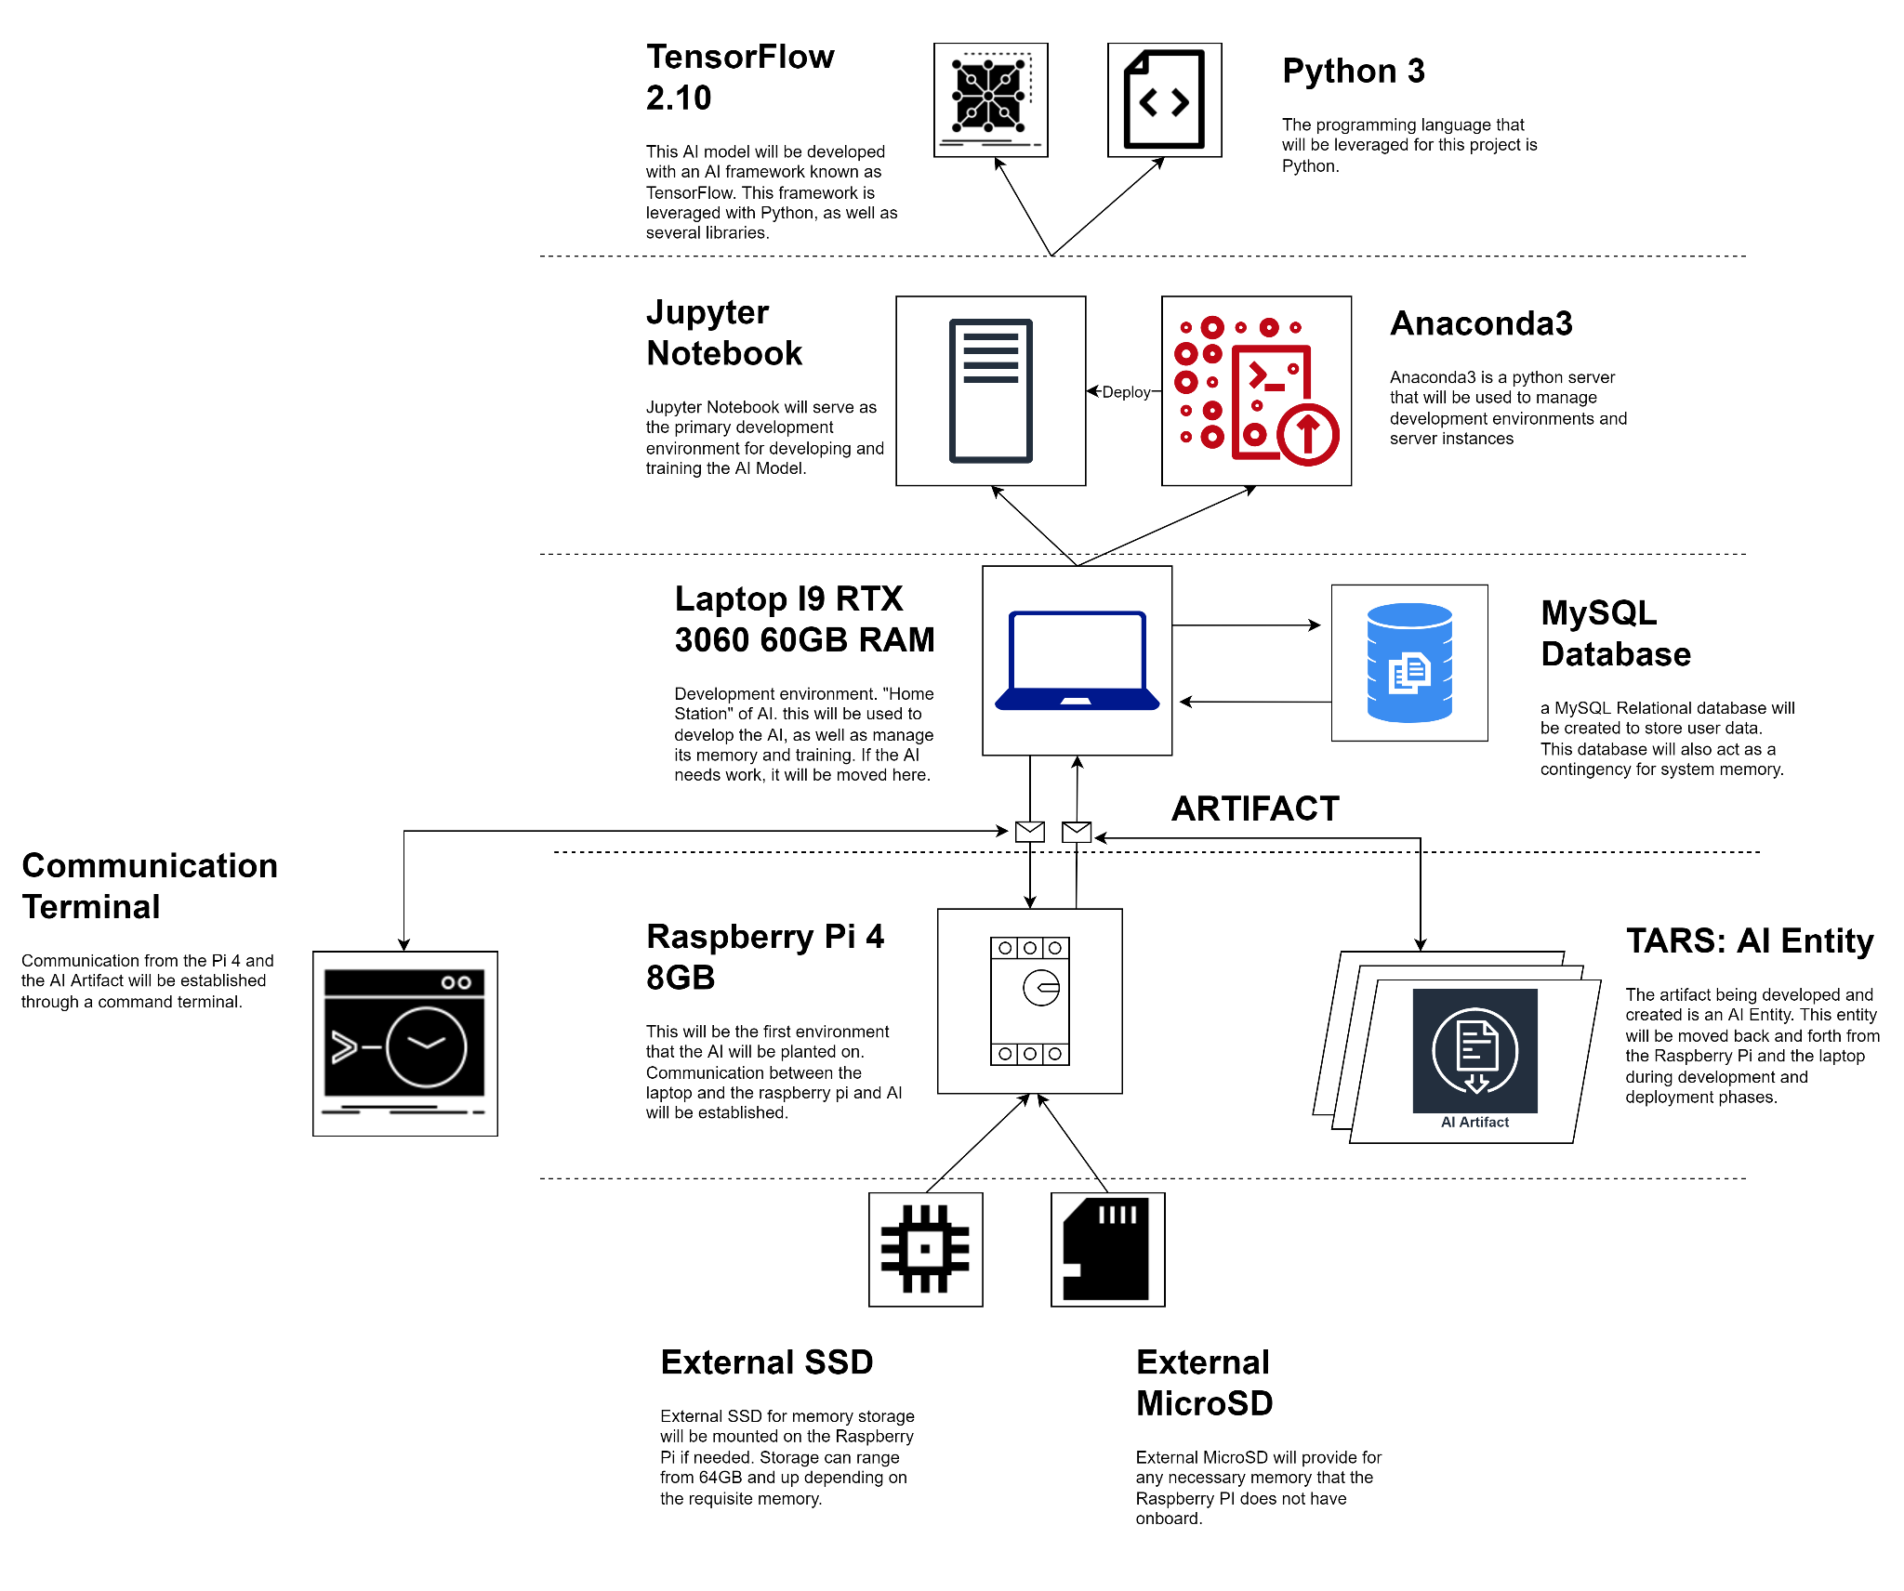

**User Interface Design**

Provide a sitemap and user interface design diagram for each user interface screen in the application, if not applicable, define the components of the project as described in the handbook.

**SITEMAP**

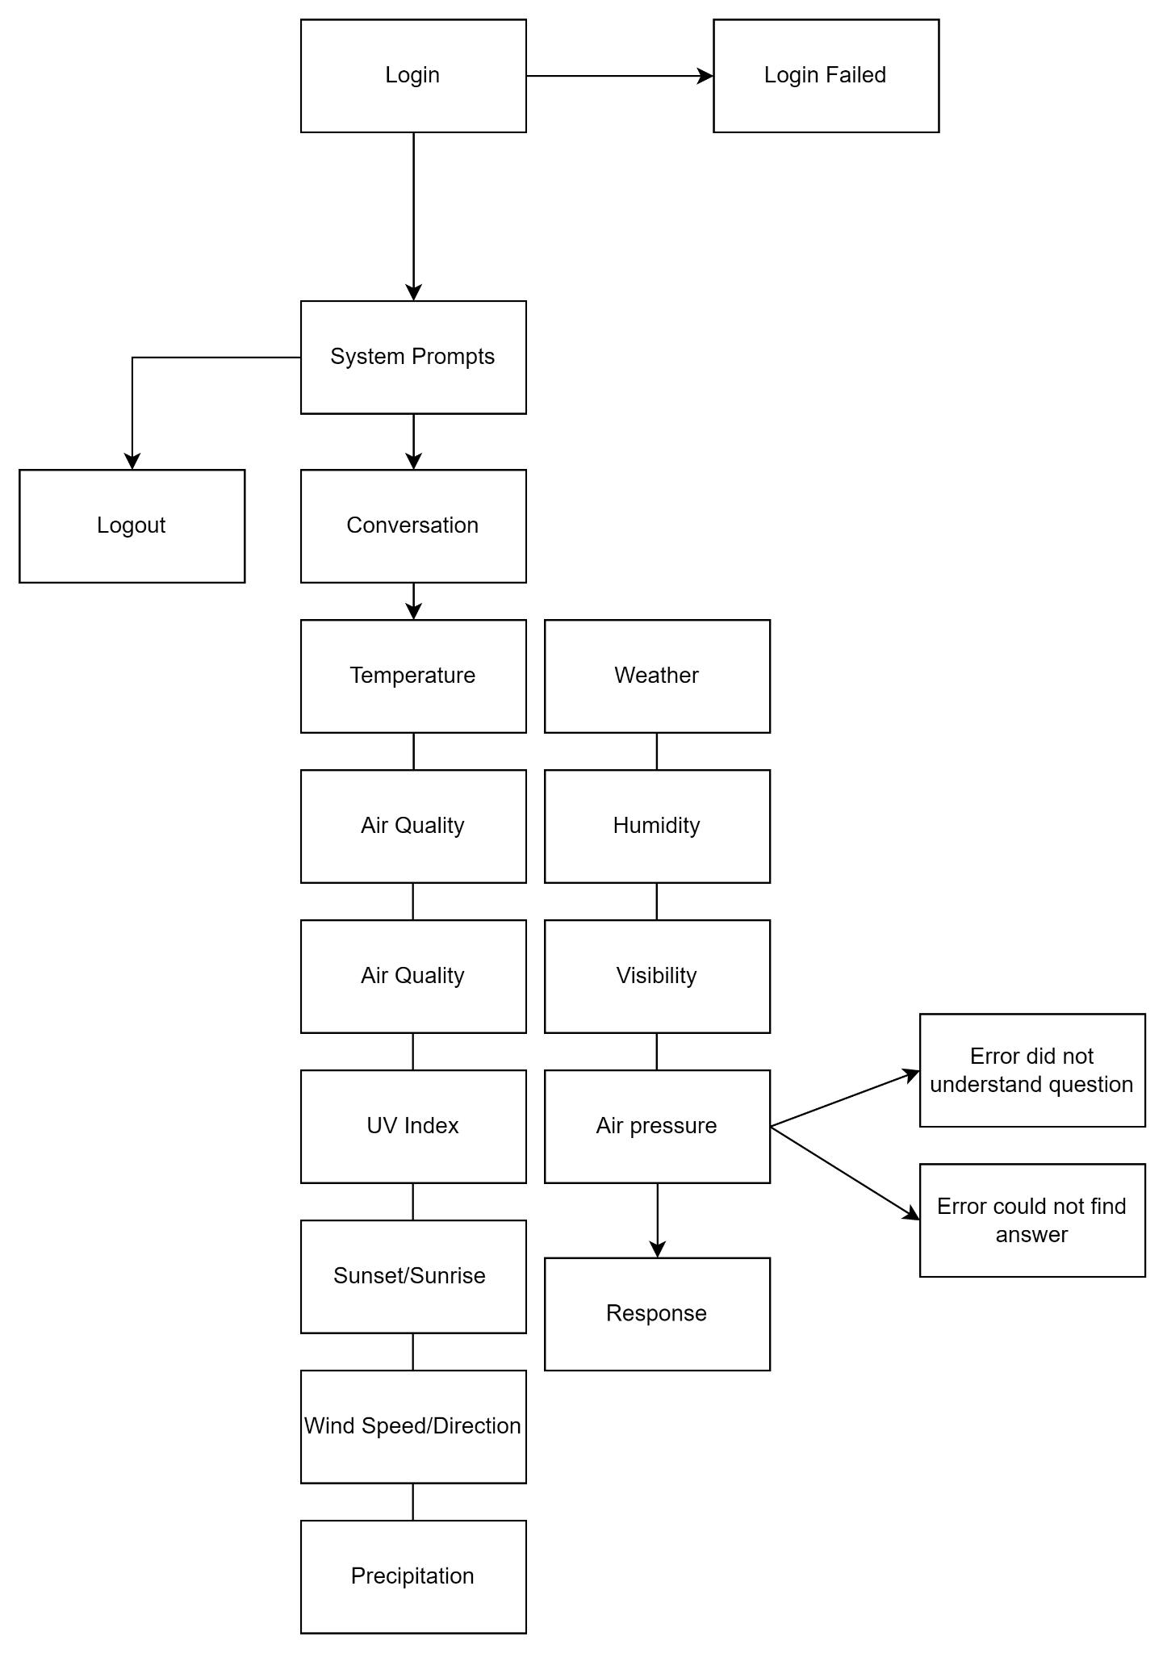

**WIREFRAME**

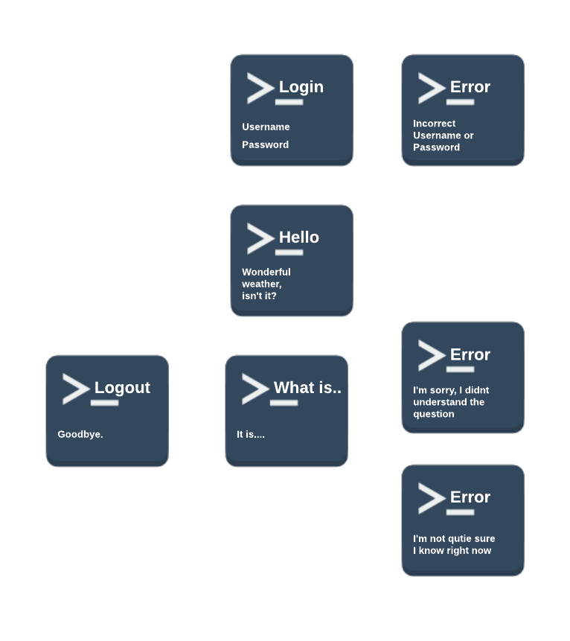

**Reports Design**

This system does not produce any reports.